CASE STUDY 10: INVENTORY AUDIT AND STOCK REPLENISHMENT SYSTEM
1 PROBLEM STATEMENT
Design and implement an automated inventory auditing and valuation module that processes product records (product ID, unit price, and stock levels), filters out malformed or invalid entries through rigorous validation rules, computes total inventory values for valid items, identifies items requiring replenishment based on a reorder threshold, and generates a comprehensive reconciliation audit summary.
2 OBJECTIVES
- Validate product record structures to ensure non-empty string IDs, positive prices, and non-negative integer stock levels.
- Separate valid products from invalid records cleanly.
- Compute individual product inventory values and aggregate total inventory worth.
- Identify items falling below the reorder level threshold and classify them as "LOW STOCK" or "OUT OF STOCK".
- Generate an executive reconciliation audit summary tracking record counts and restock requirements.
3 KEY ASSUMPTIONS
Reorder levels and record structure lengths are fixed configuration constants. Malformed, negative-priced, or negative-stock records are automatically flagged and segregated into an invalid records list.
4 ALGORITHM
- Define the reorder level threshold (REORDER_LEVEL = 10) and a raw products dataset containing mixed valid and invalid tuples.
- Implement a validation function (is_valid) to verify tuple length, string ID format, positive numerical price, and non-negative integer stock.
- Iterate through all records, appending compliant items to valid_products and malformed/invalid ones to invalid_products.
- Calculate individual item values (price * stock), aggregate the total_inventory_value, and output a formatted valuation table.
- Filter valid products with stock below the reorder level, assigning appropriate restock status flags ("OUT OF STOCK" vs. "LOW STOCK").
- Print detailed audit metrics covering total records checked, valid items, invalid entries, and restock counts.
5 FLOWCHART REPRESENTATION
Plaintext
[Start] -> [Read Raw Product Records & Reorder Level] -> [Validate Record Structure & Constraints]
-> [Valid? Yes: Add to Valid Products | No: Add to Invalid Products]
-> [Calculate Item Values & Total Inventory Worth] -> [Check Stock < Reorder Level?]
-> [Stock == 0? Flag OUT OF STOCK | Stock < 10? Flag LOW STOCK] -> [Print Audit Summary & Reports] -> [End]
6 PSEUDOCODE
Plaintext
FUNCTION is_valid(record):
IF length != 3: RETURN False
EXTRACT product_id, price, stock
IF product_id is not non-empty string: RETURN False
IF price <= 0 OR stock < 0: RETURN False
RETURN True

FOR record IN products:
IF is_valid(record): valid_products.ADD(record)
ELSE: invalid_products.ADD(record)

FOR valid product:
value = price * stock
total_inventory_value += value
IF stock < REORDER_LEVEL: flag restock status ("OUT OF STOCK" or "LOW STOCK")
8 TEST CASES
Product Record Tuple | Validation Check | Expected Outcome | Status / Reason
("P101", 250.0, 40) | Valid ID, positive price, valid stock | Valid | Included in inventory valuation
("P103", -50.0, 20) | Price is negative (-50.0) | Invalid | Segregated to invalid records
("P107", "abc", 12) | Price is non-numeric ("abc") | Invalid | Segregated to invalid records
("P108", 35.0, 0) | Stock is 0 (< Reorder Level 10) | Valid / Restock | Flagged as OUT OF STOCK
9 OUTPUT SCREENSHOTS
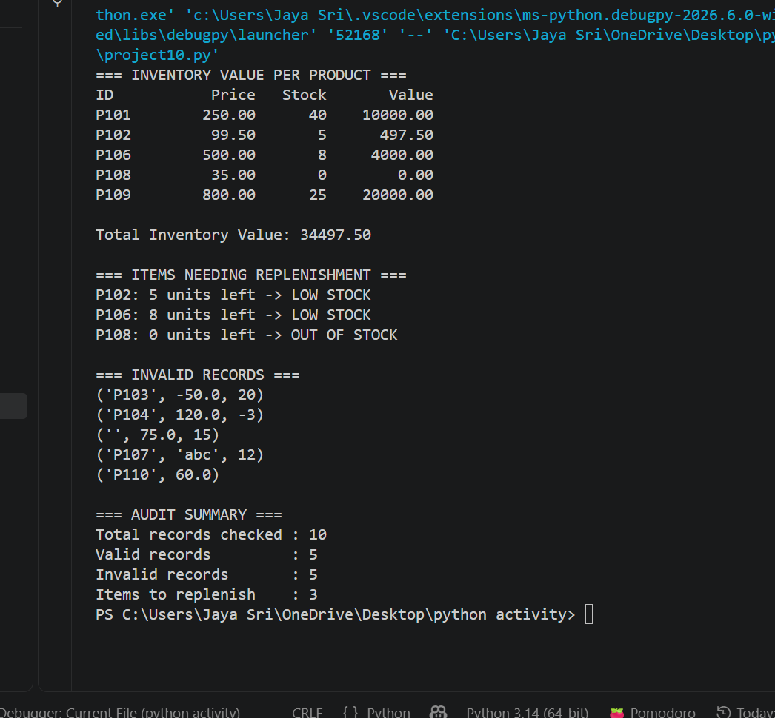

10 CONCLUSION
The automated inventory auditing system effectively safeguards against corrupted or invalid dataset entries, performs precise asset valuations, and highlights critical stock deficiencies to streamline warehouse replenishment decisions.

